Midgut Development

The midgut extends from the distal 1/3 of the duodenum to the proximal 1/3 of the transverse colon — all supplied by the SMA

Physiological Herniation
- Early in the 2nd month, the intestines elongate faster than the abdominal cavity expands
- The midgut loop herniates into the umbilical cord (extraembryonic coelom) — this is physiological, not pathological
- Axis of herniation = Superior Mesenteric Artery (SMA)
- The SMA is a remnant of the primitive vitelline circulation to the yolk sac — originally paired segmental arteries that fuse and reduce to three (celiac, SMA, IMA) by the 6th week
- At this stage the SMA still continues past the intestine to supply the vitelline stalk — the occasional persistence of which = Meckel's diverticulum

Three Stages of Midgut Development

Stage 1 — Herniation (5th week)
- Midgut buckles ventrally into the body stalk coelom
- Apex marked by the yolk stalk; axis by the SMA
- Loop undergoes 90° counterclockwise rotation
- Prearterial (cranial) limb → lies to the right of the SMA
- Caudal limb remains nearly straight; cranial limb grows rapidly and forms coils
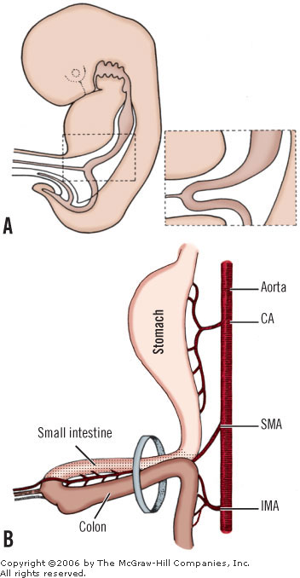

Stage 2 — Return / Reduction (10th week)
- Return is rapid and relatively sudden at ~10th week
- Cranial limb returns first — passes to the right of the SMA, duodenum passes behind (posterior to) the SMA
- Caudal limb returns later — transverse colon passes in front of the SMA; cecum is last to return
[TIP]Total rotation = 270° counterclockwise (90° during herniation + 180° during return)

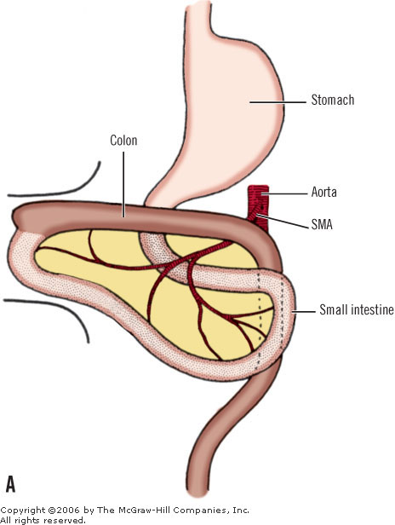

Stage 3 — Fixation (4th month → after birth)
- Mesenteries of ascending and descending colon fuse with the posterior parietal peritoneum → become secondarily retroperitoneal
- Transverse mesocolon fuses with the posterior leaf of the omental bursa
- Fixation of the duodenojejunal junction is postnatal in some — may take up to 2 years (Slovis et al.)
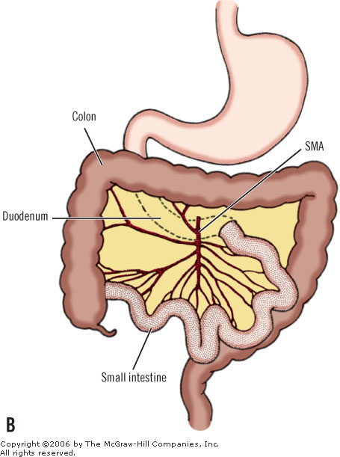

Stage | Timing | Rotation | Event
1st | 6th week | 90° CCW | Midgut herniates into umbilical cord; SMA = axis
2nd | 10th week | Further 180° CCW | Return to abdomen; total = 270° CCW
3rd | After return | Fixation | Caecum descends to RIF; peritoneal attachments form

[YOUTUBE] https://youtu.be/q-JhzsLrMsw

SMA-aorta angle:
- The 3rd part of the duodenum lies in the angle between the SMA and the aorta (having passed under the SMA)
[WARNING]This anatomical relationship is the basis for SMA syndrome (duodenal compression)

[CLINICAL]Key sequence note: Neuroblasts of the myenteric plexus migrate along the vagus nerve and follow the surface of the circular muscle — this is why circular muscle always precedes longitudinal muscle, and why ENS migration is always craniocaudal. The distal colon is innervated last, explaining why Hirschsprung disease almost always affects the rectosigmoid region first.

Clinical Correlations

Malrotation
- Incomplete counterclockwise rotation — the midgut loop does not complete its full 270°
- Duodenojejunal junction fails to pass to the left of the SMA → lies in the midline or right of midline
- Creates a narrow mesenteric pedicle → risk of midgut volvulus (clockwise twisting → ischemia of entire small bowel)
- Ladd's bands: peritoneal bands from the malpositioned caecum crossing the duodenum → duodenal obstruction

Midgut Volvulus
- Life-threatening; presents with bilious vomiting in a neonate — bilious vomiting in a neonate is midgut volvulus until proven otherwise
- Upper GI contrast: "bird's beak" / "corkscrew" appearance of duodenum
- Treatment: Ladd's procedure (detorsion, division of Ladd's bands, appendicectomy, widening of the mesenteric base)

SMA Syndrome (Wilkie's Syndrome)
- Compression of the 3rd part of the duodenum in the angle between the SMA and the aorta
- Predisposed by: low body weight/loss of fat pad (eating disorders, post-surgical), prolonged supine positioning, rapid height gain in adolescence
- Not a true congenital defect; a predisposition exists in some individuals based on a narrow SMA-aortic angle
- Presents with postprandial epigastric pain, bilious vomiting, weight loss

Meckel's Diverticulum
- Persistence of the vitello-intestinal (omphalomesenteric) duct
- SMA supplies it — confirming its embryological midgut origin
- Rule of 2s: 2% population, 2 feet (60 cm) proximal to ileocaecal valve, 2 inches long, 2 types of ectopic tissue (gastric most common, then pancreatic), symptomatic in first 2 years
- Gastric mucosa → ulceration → painless rectal bleeding in children
- Technetium-99m pertechnetate scan detects ectopic gastric mucosa

Hirschsprung Disease
- ENS migration failure — neural crest cells do not reach the distal bowel
- Always starts at the internal anal sphincter and extends proximally for a variable length
- Short-segment (rectosigmoid) ~80%; long-segment ~15%; total colonic ~5%
- RET mutation most common; also EDNRB, GDNF, SOX10, PHOX2B
- Presents as failure to pass meconium in first 48 hours; chronic constipation; enterocolitis (feared complication)
- Diagnosis: suction rectal biopsy (absent ganglion cells + hypertrophied nerve trunks + increased acetylcholinesterase staining)

Omphalocele vs Gastroschisis (herniation defects)
Feature | Omphalocele | Gastroschisis
Covering | Peritoneum/amnion sac | None
Location | Central (umbilical ring) | Right paraumbilical
Associated anomalies | Common (Trisomy 13, 18; BWS) | Rare
Maternal age | Older | Younger
Pathogenesis | Failed return of physiological herniation | Vascular disruption / lateral fold defect
SMA relevance | Gut not rotated | Gut may not rotate

Key Points to Remember
- Total midgut rotation = 270° counterclockwise in two phases (90° during herniation + 180° during return)
[TIP]Cranial limb returns first — passes behind (posterior to) SMA; duodenum becomes retroperitoneal
- Colonic villi are present in fetal life but disappear after birth — unique to colon
- Circular muscle always before longitudinal muscle — ENS neuroblasts follow circular muscle surface craniocaudally
- DJ junction position (not caecal position) is the reliable landmark for diagnosing malrotation
- Fascia of Treitz ≠ Ligament of Treitz — a commonly confused pair

